**Design Report of an electric-BLDC-powered, propeller driven, radio controlled, heavier-than air aerial vehicle**

*Submitted by*

**Team GlideX**

*of*

**NIT Trichy**



**Team Members:**

Somnath Swain

Tamoghno Saha

R Surya Narayan

Rajesh

Amal K Johnson

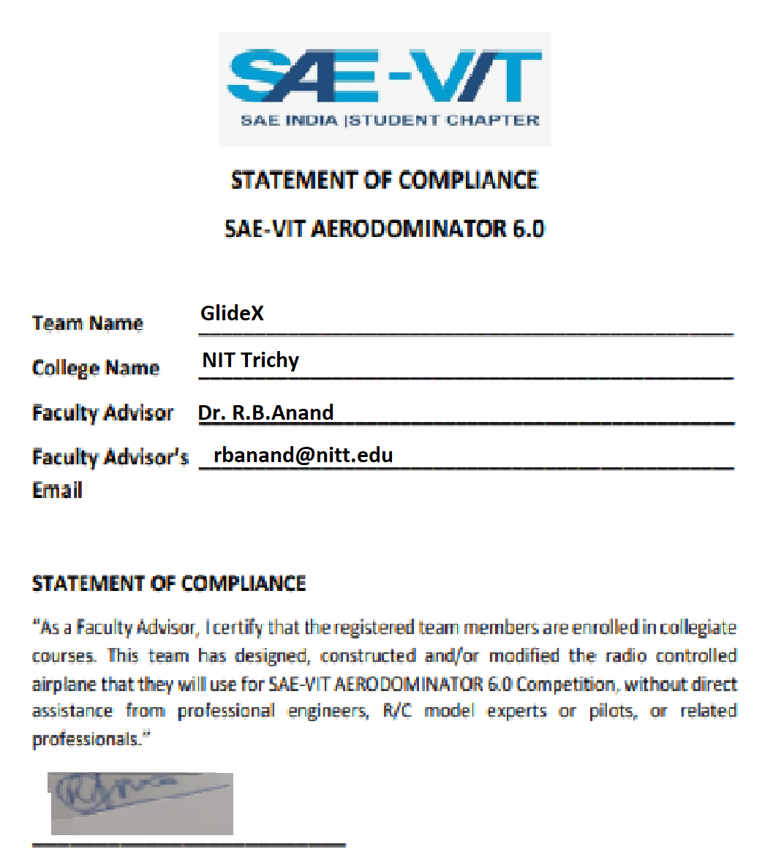

# Project Abstract

The following document is a design report that gives to sufficient detail the necessary rationale behind the decisions taken in relation to design of a micro-class aerial vehicle keeping in mind the constraints imposed by the organizers of the competition. These include constraints on the use of electronics to monitor the maneuverability of the aircraft. The challenge thus imposed required the design of a plane capable of executing maneuvers while being stable due to its design during cruise.

# Velocity estimate of the plane

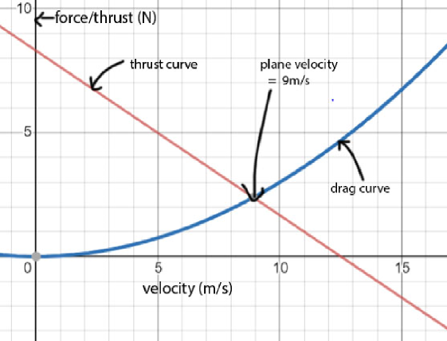The first step we chose to work on is the velocity of the plane because a reasonable estimate on the velocity of the plane will enable us to tweak the Reynold’s number of flow to a desirable range where the airfoil operates to sufficiently overcome the weight of the plane at small angles of attack. Reynold’s number for an airfoil is defined as:

Where C is the chord of the airfoil; v is the velocity of flow around the foil and ν is the kinematic viscosity of air (=1.655x10-5 stoke). We approached the problem mathematically by modeling a blade element of the propeller at 70 percent of the radius of each blade as done most often in propeller blade element theories. We used a constant pitch propeller that has same AoA at all sections for a given velocity. The net aerodynamic force this section generates is resolved as the thrust force it provides and the force responsible for creating the counter-torque and deciding the RPM of the motor. The equation for the thrust therefore is calculated by applying the basic airfoil lift equation and resolving forces.

Hence a decision on the type of motor to be used was taken. **As an estimate we used a BLDC 1200kV motor powered by 11.7 V LiPo batteries.** We measured the RPM of the propeller blades at normalized cruise **throttle of 75%** using a **tachometer** as **5650**. **The pitch angle of most commercial RC propellers is around 7 degrees.** Fixing these data, the thrust as a function of velocity was plotted. A generalized drag function of velocity was generated by taking previous year data of drag encountered for similar planes. The point where both curves intersect (figure given above) is the point where the aircraft should ideally cruise at. This was obtained at **9m/s** for the given specs.

# Wing design

We wanted a design of the wing that could help us maximize our payload fraction, maximize lift and minimize drag. The two most important features of the wing are its geometry and the airfoil; the parameters required for unambiguously defining a wing and ensure ease of fabrication. While designing the geometry of the wing we took into account the span, aspect ratio and the planform of the wing.

# Airfoil selection

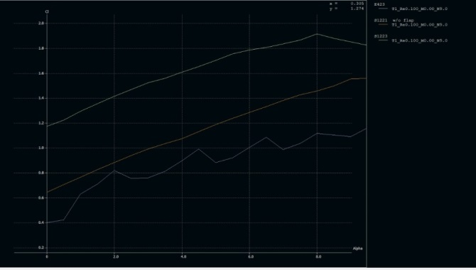Our requirement was an airfoil that gives high lift has a high angle of stall and a roughly constant pitching moment. Ideally these are the ones with high camber. We initially consider airfoils that will have favorable characteristics in the conditions at which our plane will operate i.e. low speed, low Reynolds number conditions. Using this, we narrowed the number of airfoils down to 3, namely E423, S1221 and S1223. Out of these S1223 had the most favorable lift characteristics, whereas the other factors were similar amongst the 3. Hence s1223 was the airfoil we chose.

# Span:

The payload fraction of an aircraft in relation to the span can be obtained by applying the definition of the quantity and simply taking cruise conditions:

Where Wr denotes the weight of the plane excluding the wings and φ is the areal density of the wing. The rest of the symbols have their usual meaning. According to the function given in the rulebook, the span peaks at 154cm, however one has to account for the bending of the cantilevered wing as well. We set our span at 115 cm to ensure that we got sufficient lift and at the same time there isn’t much anhedral caused due to bending moment.

# Aspect ratio

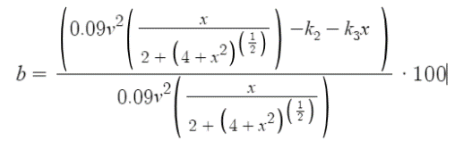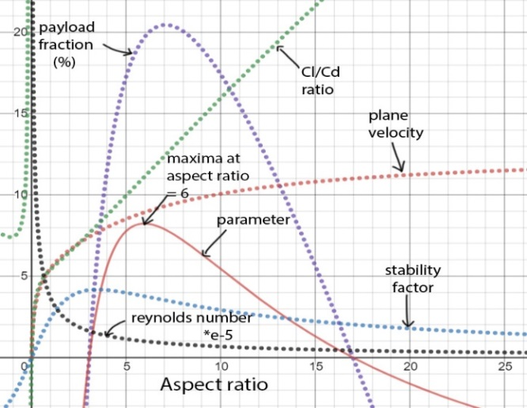Aspect ratio influences several properties of the aircraft. In order to arrive at an appropriate aspect ratio, we constructed a function that considered the properties that were influenced and decided to use the aspect ratio that corresponded to the maxima of the function. The properties considered were the payload fraction, cl/cd ratio, Reynolds number of flow and the stability of the aircraft. Our function was the product of these parameters as functions of aspect ratio. This allowed us to choose a value of aspect ratio that ensured that most of these parameters had reasonably high values. These are listed below. The corresponding graph is also given. b = payload fraction, l = Cl/Cd ratio, c= stability factor, v= velocity, r= Reynolds number. The final function we plotted was a product of all the ones listed below.

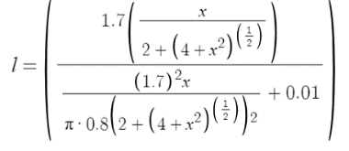

# Planform

The planform of the wing determines the wing efficiency and will affect the induced drag produced for a given span and aspect ratio. Mathematically it is expressed in the equation:

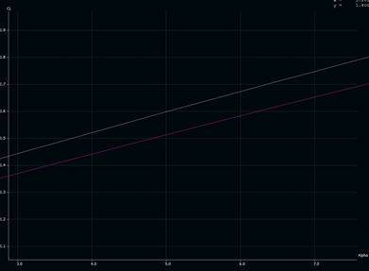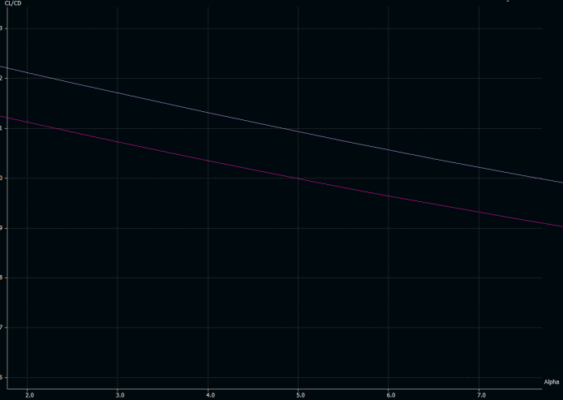Here *e* is the planform efficiency factor. The wing planform that has the best efficiency is the elliptical wing but it’s hard to manufacture. A rectangular wing on the other hand is easy to manufacture but is not very efficient. The middle ground is a tapered wing whose efficiency and (**above, left: *XFLR5 Analysis comparing rectangular and tapered wing planforms)*** ease of manufacture is between the other 2 planforms. Hence for reduced induced drag while still **(above, right:*Graphs of lift and wing efficiency vs. angle of attack for the two wing planforms*)** keeping the wing easy to manufacture we have made our wing into a tapered wing. Then a proper taper ratio was defined for the wing, keeping in mind the minimum Reynolds number of flow we wanted while deciding the length for the tip chord. Then the root chord was modified to maintain the aspect ratio we wanted. The wing was later analyzed in Ansys Fluent for its lift, drag etc. The drag curves data was used to calculate the velocity for the second iteration. The result of the second iteration didn’t alter the initial estimate much.

# Empennage design

The sensitivity of pitch is determined by horizontal tail volume coefficient given by:

Where, SH=horizontal tail area, LH=horizontal tail moment arm, S=reference area (wing area), c=wing chord (mean aerodynamic chord). A well-behaved aircraft has VH in the range of 0.3 to 0.6, LH at 55% of fuselage length which gives us 42 cm. Taking VH as 0.3 we get area of horizontal stabilizer as 300 cm2. Hence the sum of root and tip chord, Croot+Ctip, is 20. For easy movement of elevator, we take Ctip=6 and hence Croot=14. The aspect ratio of horizontal tail should be in range of 3 to 5 and taper ratio should be 0.3 to 0.6. Therefore, taking aspect ratio=3 we get span of horizontal stabilizer to be 30 cm. Its effectiveness is controlled by vertical tail volume coefficient given by:

Where Sv=vertical tail area, Lv=vertical tail moment arm, S= wing area, b=wing span. Most well behaved aircraft have Vv in range 0.02 to 0.05. A T-Tail specification should have the height of vertical tail somewhere around 50% of horizontal span (as a reasonable approximation) which gives us its height as 15 cm. For a T-Tail the aspect ratio should be 0.7 to 1.2. Taking it as 1.2 we get area of vertical stabilizer as 187.5 cm2. Taper ratio should be 0.7 to 1.2. Taking it as 0.6 we get Cr=15.6cm and Ct=10cm. Lv= 52.5-9+(16-0.75\*13.23) -(22-0.75\*19.16) =41.94. By substituting all values in above equation, we get value of Vv as 0.0325 which fall in the range and is suitable for use in our aircraft.

# Drag analysis and propulsion requirement

A drag force is the resistance force caused by the motion of a body through a fluid, such as water or air. A drag force acts opposite to the direction of the incoming flow velocity. It is calculated by

Where Cd is the coefficient of drag, ρ is the density and V is the velocity and A is the projected area in which drag is to be found.Drag values changes as AOA changes not only due to change of pressure drag but also the horizontal component of lift also gets add on the drag when plane is not at zero AOA.

This gives a total drag of

Where W is the lift produced by that AOA and alpha is AOA. The magnitude of drag force is of immense important for motor sizing cause the thrust produced by motor has to balance the drag force of the plane during flight and according to acceleration requirement extra trust has to be provided. We have provided data from 5 to 10 deg. AoA

|  |  |  |  |  |  |
| --- | --- | --- | --- | --- | --- |
| **Angle of attack** | **CL** | **CD** | **Lift (N)** | **Drag(N)** | **Total drag(N)** |
| 5 | 1.596 | 0.146 | 17.3 | 1.58 | 3.08 |
| 6 | 1.671 | 0.158 | 18.11 | 1.71 | 3.60 |
| 7 | 1.716 | 0.171 | 18.60 | 1.85 | 4.12 |
| 8 | 1.819 | 0.184 | 19.71 | 1.99 | 4.73 |
| 9 | 1.891 | 0.198 | 20.49 | 2.14 | 5.34 |
| 10 | 1.961 | 0.212 | 21.25 | 2.29 | 5.98 |

The maximum drag encountered is 6N. The motor- prop configuration we chose was a 1200kV motor with 10\*4.5 inch propeller which was enough to overcome the drag we encountered.

# Fuselage and payload design

Our fuselage is made up of **Depron** and reinforced by **aero-ply and balsa**, as reinforcing of complete fuselage will make it heavy, we cut parts in the middle of the aero-ply by doing topology optimization at less stress concentrated zones. Also the payload bay was designed in a way to have sufficient volume and was positioned at the center of gravity of the plane without the payload. This was done to ensure even after the payload was placed in the box or removed the aircraft CG didn’t shift.

# Aircraft stability and control

# Longitudinal static-stability analysis

The stability of the plane can be altered to various degrees by positioning the COG and neutral point of the plane accordingly. To provide an analytical basis to the stability of the plane and look at the effects of various parameters that influence the plane stability along the longitudinal axis, a generalized moment equation about the COG of the plane was used. A trim of 5 degrees was used for the wing to get the desired lift for the aircraft to balance its weight. This was then altered by converting all terms of the equation into coefficients instead of forces. Required data was plugged in from XFLR 5 analysis of the wing. The simplified equation reads:

Expanding the terms within the stall region:

The various symbols mean the following: ***Cm*** - The moment coefficient of the plane, ***Cmac***- The moment of the wing of the plane about the mean aerodynamic chord, ***CLo­p***- The lift coefficient of the plane at zero angle of attack, ***Sp***: The slope of the lift coefficient-alpha curve for the plane, ***α***- Angle of attack without trim, ***5***- trim setting for the wing, ***At***- Area of the elevator, ***Aw***- Area of the wing, ***CLo­e***- Lift coefficient of the elevator at zero angle of attack, ***Se***- slope of the elevator lift coefficient-angle of attack graph, ***t***- Trim setting of the elevator, ***ε0***- downwash angle for the elevator placed in line with the wing, ***β****-* Elevation angle of the elevator from the MAC of the wing for a T-tai, ***lcg***- Distance of the COG of the plane from the MAC, ***VH***- Volume coefficient of the horizontal stabilizer = SHlH/SC (with **lH** and **SH** denoting the distance of the horizontal stabilizer from the MAC of the wing and the total area of the elevator respectively). Differentiating the simplified equation above and setting it less than zero for longitudinal stability, we arrive at:

At neutral point:

The slopes can be gotten readily from the graphs of XFLR5. The chord is fixed at 19.16 (Mean Aerodynamic Chord). To evaluate the downwash effects, consider the following equation:

Differentiating:

denotes the derivative of the lift coefficient for the plane and the same for the other notation used in the above equation. Thus, plugging in data into this from XFLR5 and using the result in the equation for neutral point, we get theoretically the value of the neutral point as measured from the leading edge of the wing (as taken from the MAC) as **9.54 unit**s. This now allows examining the degree of stability of the plane. The degree of stability depends on the magnitude of a parameter ‘SM’ (Short for Static Margin) defined as:

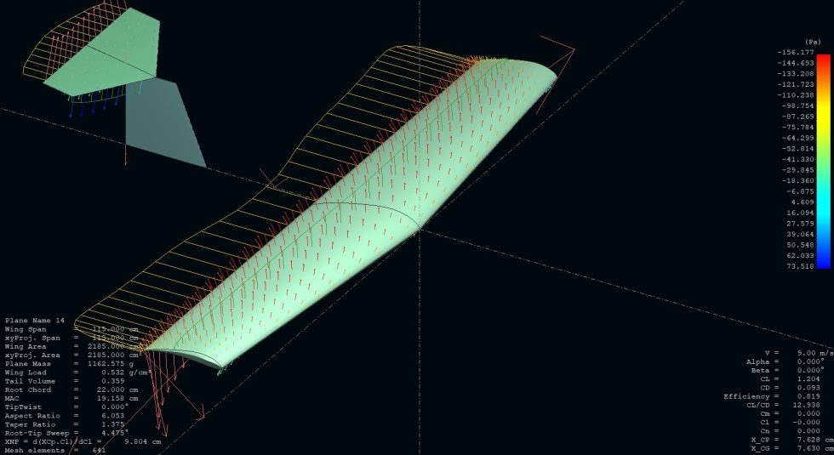

For stable planes the value of SM should be between 0.05 and 0.25, with the stability getting smaller with smaller values of the static margin. For the plane with neutral point at 9.54 units from leading edge we have a SM of 0.09. This is quite reasonable as it falls on the mid-**(alongside: *XFLR5 analysis of our T-tail****)* range side of the prescribed values-neither too stable to resist pitching when elevators are pulled-up or down by servos or too unstable to get into haphazard phugoids. **The longitudinal stability analysis was performed directly using XFLR5 and the results obtained showed the neutral point location at** **9.87 units.** The closeness of these values indicated the accuracy of the theoretical model used for the longitudinal stability of the aircraft. This is also an indication that the software considers the downwash effects for a T-tail configuration as well. **An investigation on the difference in values that XFLR5 throws and what the equation predicts was done.** The equation of the neutral point was evaluated in 4 cases: 2 that included downwash and 2 that didn’t, and 2 that included the exact slope ratio and 2 that approximated the slope ratio to 0.5 (according to the Piercy approximation by wikipedia). In the four cases mentioned above, the ones that didn’t include downwash showed significantly different values. However the ones that had downwash effects showed closeness of values. Nonetheless, the approximation that included the slope ratio as 0.5 showed close resemblance to the value that XFLR5 throws**. Hence the corrected static margin for our plane was 0.15-close to the stable region but nonetheless sufficiently unstable**. Also one can get Cm-α curve for the aircraft approximately from the equation given above. **We want our plane to cruise and stabilize at a pitch angle of zero degrees so that the angle of attack of the wing is equal to the trim setting we put (which is 5 degrees).** Therefore the curve must pass through the origin. Setting values of Cm from XFLR at α=0 for a zero trim in the expanded equation we get a resultant downwash angle as -8.3 degrees. **For all practical purposes we use the value of lcg as zero as efforts are usually made to keep the COG close to the Mean Aerodynamic Chord.** Hence following ease of fabrication lcg=0. Assuming this doesn’t change appreciably at a different angle of attack (i.e. the angle β remains constant with angle of attack variation) or a change in the elevator trim, we introduce a trim of ‘t’ for which the value of Cm­ vanishes. Calculating this trim from the equation, we arrive at a ball park trim of **-10 degrees**. Tweaking the values of trim inXFLR5 close to -10 degrees, we arrive at our desired graph at an exact trim of **-9.5degrees.** Fractional values of angles are harder to fabricate and incorporate into designs. Hence challenges in fabrication limit our values to -10 or -9 degrees.

# Aircraft roll stability and aileron sizing, responsiveness

The aircraft was examined for its responsiveness for the aileron actuation as some hiccups were encountered during test-flight. To investigate this and ensure we have adequate aileron sizing, we chose to approach the problem analytically. Aircraft roll due to aileron actuation happens due to the change in lift caused due to the alteration in the camber of the airfoil. This was integrated over the strip of the wing that had the aileron and the rolling moment due to the aileron actuation for 20 degrees was calculated. What opposes this moment is the rolling moment of the rudder caused due to cross-wind, a factor that stood out quite starkly during all our test flights. The moment due to the rudder was also calculated by assuming cross-winds of 4m/s. As a result, we coined a roll-responsiveness parameter φ that is the ratio of the rolling moment caused due to the rudder to the ailerons. Greater this value smaller the responsiveness and vice-versa. (***The following images examines the effect of airflow over our plane and shows the pressure contours)***

Here vcross, vplane denote the cross-wind velocity and the plane velocity, b is the span, l is the aileron length, AR denotes the aspect ratio of the rudder, yv the centroid position vertically from the fuselage of the rudder, δA the deflection of the aileron in degrees and CLwing the slope of the lift coeff. Vs alpha graph and Croot the length of the root chord. An appropriate value of the parameter φ can be used to calculate the size of the aileron

# C:\Users\SURYA\Desktop\lift ansys.JPG

# 2-D drawings

# C:\Users\SURYA\Downloads\IMG_20191004_055415.jpeg Fabrication photos

**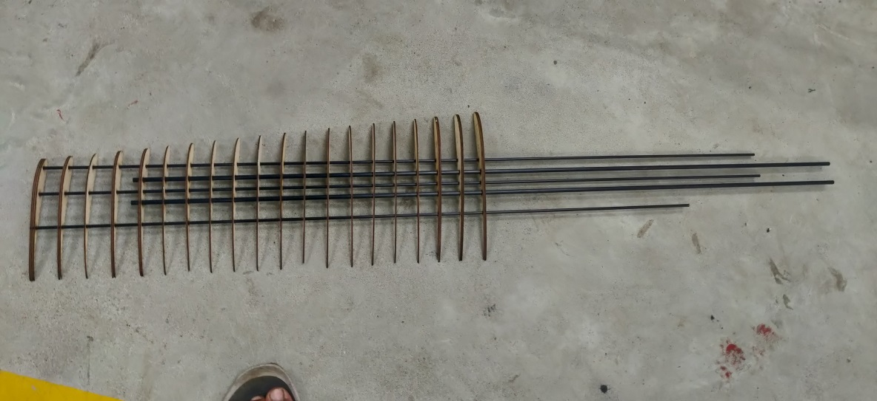**payload bay fuselage

**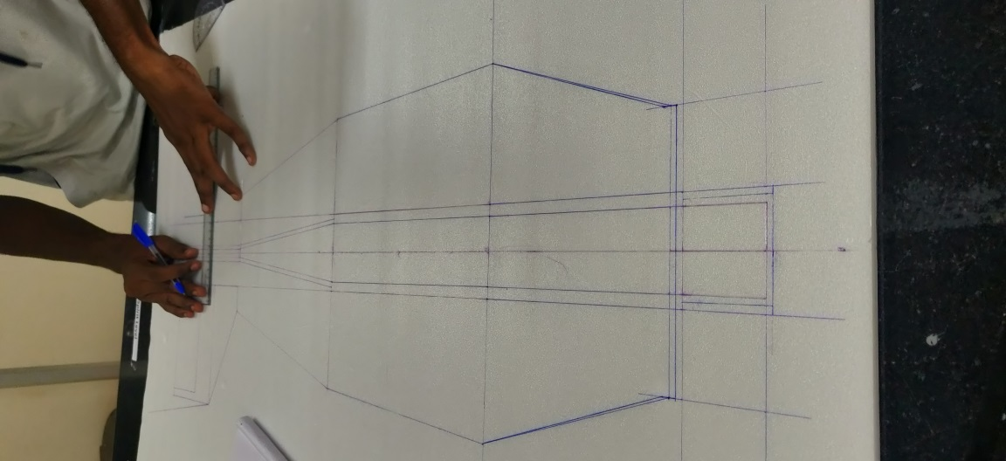**Wing under construction

Fuselage about to be cut from a depron sheet